MULLED WINE
JUMP TO RECIPE 165 COMMENTS »
This post may contain affiliate links. Please read my disclosure policy.
This traditional homemade mulled wine recipe is incredibly easy to make and always SO cozy and delicious.
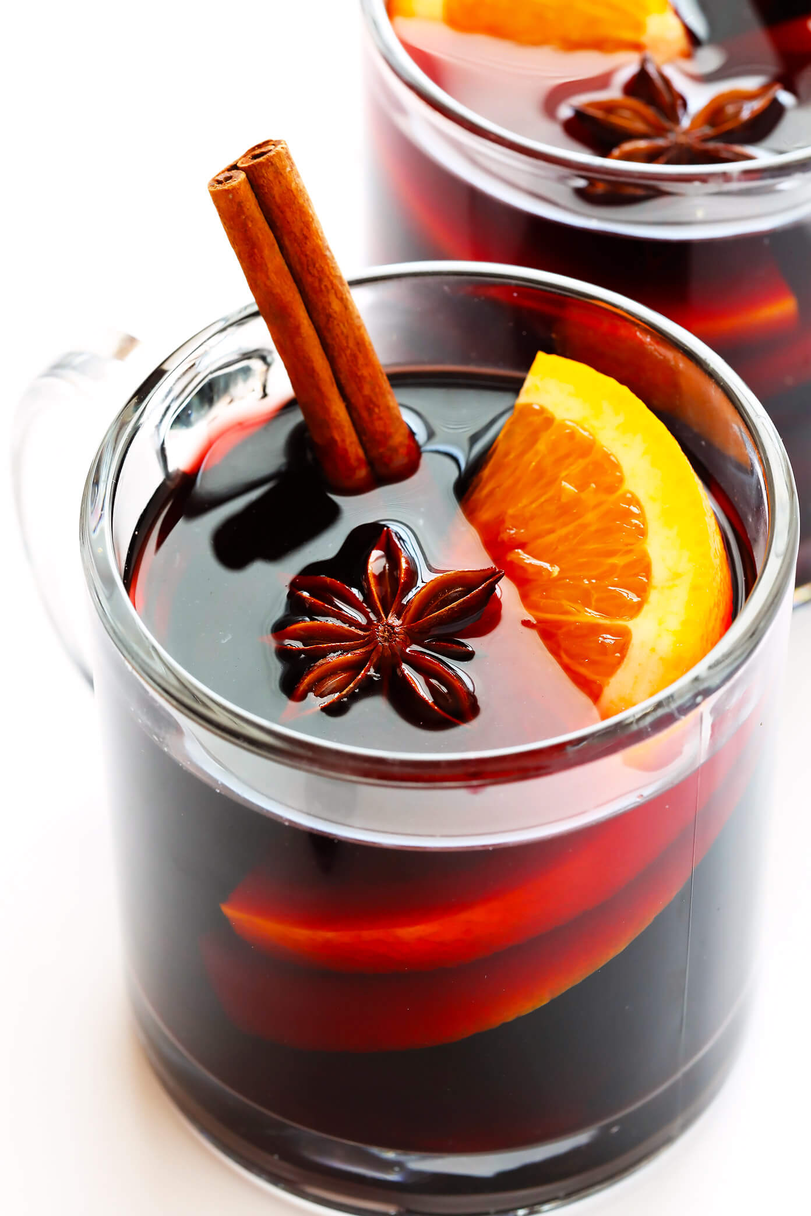
Mmmmm…mulled wine. ♡
Also known as glühwein, vino caliente, glögg, vin brulé, bisschopswijn, vin chaud, candola, vinho quente…or literally a hundred other names, depending on where in the world life may find you. Needless to say, it seems like just about everyone in the world loves some hot wine. And clearly, I can vouch that you all do too!
I actually first shared this recipe five years ago this month, after returning home from a chilly trip to Spain and England in 2012, where my friends I loved warming up mugs of hot wine each evening in the pubs. Since then, literally hundreds of thousands of you have pulled up this recipe to simmer warm batches for yourself. (Amazing!) And I ironically now find myself living back in the continent where I first fell in love with the drink, where we have been served warm mugs of mulled wine at nearly every holiday gathering and Christmas market and food festival we attend. In our first holiday season away from home, this festive drink has felt more comforting and nostalgic and delicious as ever.
So today, in honor of my mulled wine recipe’s 5 year-iversary on the blog, I thought I would bump it back up to the top of the site (along with a new step-by-step video and fresh photos) for those of you who may also looking to simmer a cozy batch for yourself this winter.
Because after having made this recipe dozens and dozens of times myself over the years, I am absolutely convinced that homemade mulled wine just about the easiest recipe ever for winter and holiday entertaining. Truly. It literally just takes about 5 minutes to prep and can be made either on the stovetop or in a slow cooker. It’s easy to scale anywhere from a “date night” to two…up to big holiday parties with dozens. It’s totally customizable with your favorite spices and liqueurs. And it’s guaranteed to make your home smell absolutely amazing and warm everyone up on a chilly winter night.
So grab a bottle of wine and let’s get to mulling!

MULLED WINE RECIPE | 1-MINUTE VIDEO

My original photo for this recipe from 2012. :)

MULLED WINE INGREDIENTS:
To begin, gather your ingredients. For this mulled wine recipe, you will need:
- Wine: No need to splurge on a pricey bottle — a mid-range bottle of dry red or white wine will do. (Or if you’re making a big batch, this is a great recipe to break out a nicer boxed wine too!) The best wine for mulled wine will be fruity and full-bodied, so that it can withstand the heat and not have its flavor completely drowned out by the aromatics. I recommend looking for a bottle of Zinfandel, Merlot, Grenache,
- Brandy: Similar to sangria, it’s also traditional to spike your mulled wine with an extra bit of liqueur. Brandy is the traditional choice, but Cointreau (or another orange liqueur) or tawny port are also delicious alternatives.
- Fresh oranges: One of which we will slice and mull in the wine, one of which you can slice and use as a garnish if you’d like. (To minimize bitterness, feel free to peel the orange before simmering it in the wine.)
- Cinnamon: I love the making mulled wine with cinnamon sticks, but you could whisk in some ground cinnamon if that’s what you have on hand.
- Mulling spices: These vary in mulled wine from country to country, but whole cloves and star anise are my favorites, plus perhaps a few cardamom pods.
- Sweetener: Feel free to add your favorite sweetener to taste. Sugar is classic, but I prefer to naturally sweeten mine with either maple syrup or honey.
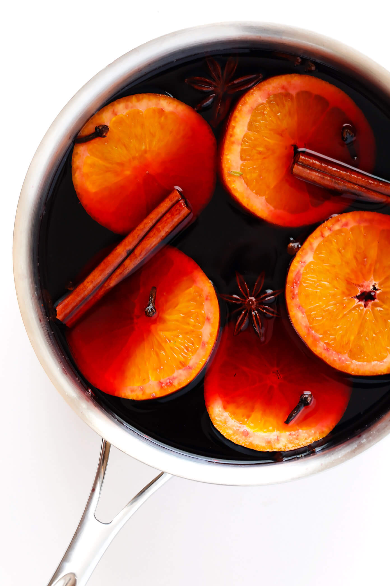

HOW TO MAKE MULLED WINE:
To make mulled wine, simply…
- Combine ingredients. Combine all ingredients in a saucepan and give them a quick stir.
- Simmer. Heat until the wine almost reaches a simmer over medium-high heat. (Avoid letting it bubble in any way. Alcohol begins to vaporize at 172°F, so take care to ensure that the wine does not evaporate.) Reduce heat to low, cover completely, and let the wine simmer for at least 15 minutes or up to 3 hours.
- Strain and season. Using a fine mesh strainer, remove and discard the orange slices, cloves, cinnamon sticks, star anise and ginger. Give the mulled wine a taste, and stir in your desired amount of extra sweetener if needed.
- Serve. Serve warm in heatproof mugs, topped with your favorite garnishes.
Full ingredient amounts/instructions listed in the recipe below.
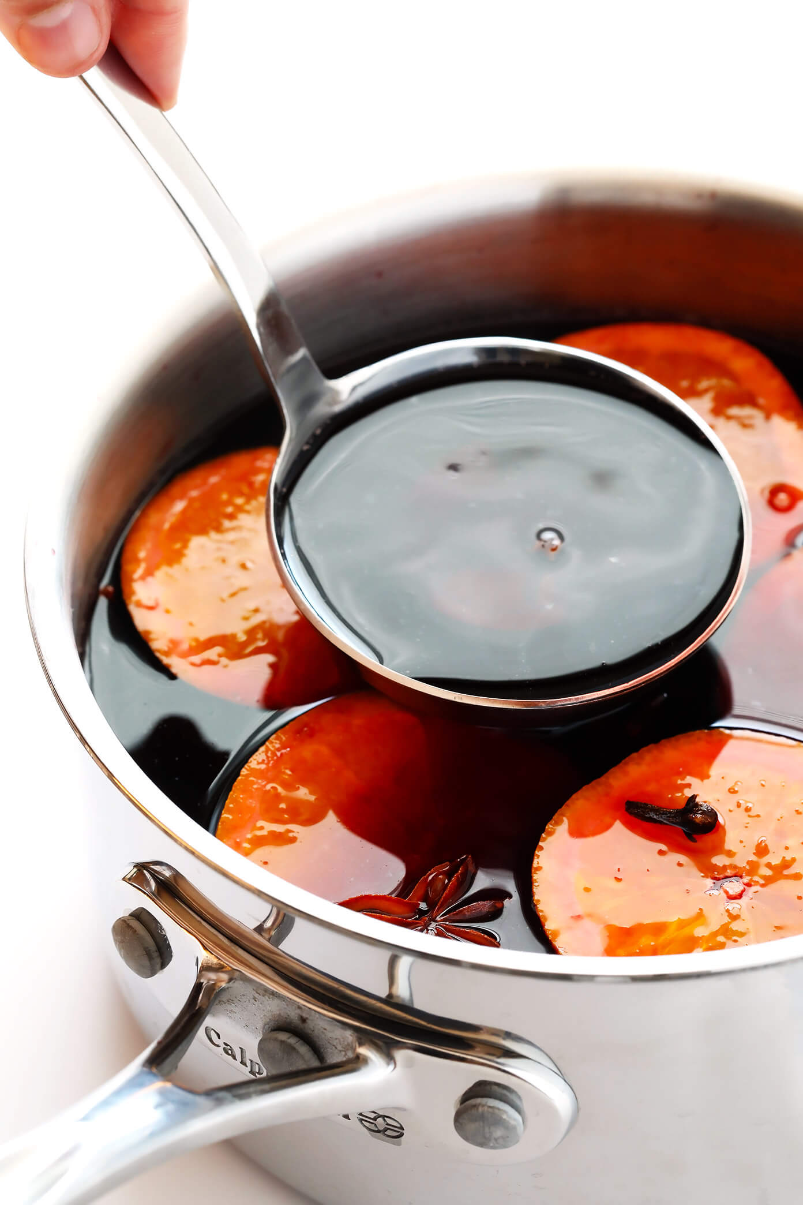

POSSIBLE VARIATIONS:
Want to customize this mulled wine a bit? Feel free to…
- Use white wine: This recipe is also delicious (and lovely) when made with a dry white wine.
- Use a chai tea bag: In place of the cloves and star anise, feel free to steep 1 or 2 chai tea bags in the mulled wine (preferably caffeine-free, if you are serving this to a group in the evening).
- Add different aromatics: Feel free to add in whatever aromatics sound fun! Fresh ginger slices, cardamom pods, nutmeg, allspice or lemon zest are some other great aromatics to try.
- Add garnishes: For a festive touch, feel free to sprinkle some fresh cranberries in the pot a few minutes before serving.
- Make Crock Pot mulled wine: You are also welcome to try making mulled wine in the slow cooker with the setting on low. I just want to clearly caution that slow cookers can run the gamut when it comes to what they consider a “low” temperature. So if you use a slow cooker, be sure to keep a very close eye on it to ensure that the wine is not accidentally overheated and simmering.

